Let us consider a data cube of Dealerships supply chain with three dimensions: Car, Time, Dealership and one measure Quantity. The dimension Car contains information about CarName, Make and CarYear. The hierarchy of the dimension Dealership contains DealershipName, street, city and country. However the dimension Time records data about quarter and year.

1. Give a full snowflake schema for the Dealerships supply cube.
2. Give query samples for the OLAP operations: drill-down, roll-up, slice.
3. In SQL format.
4. Using SQL Data Tools 2013.
5. Using SQL Data Tools 2013, give a table that allows you to display information of supply quantity by considering all levels of dimension hierarchies.
6. SnowFlake Schema:

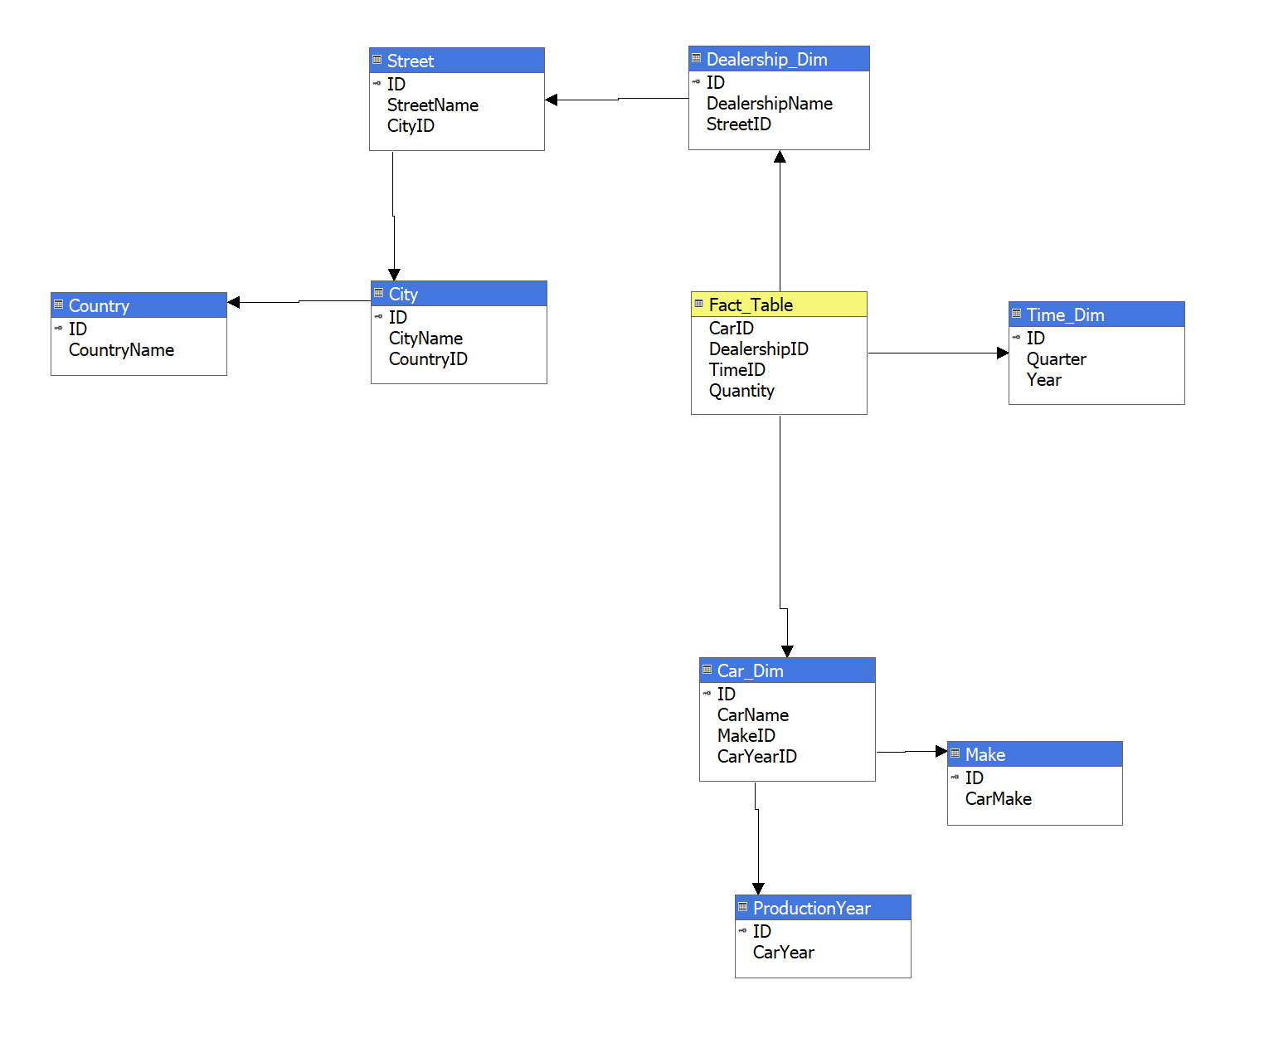

2.A.1: Drill Down using SQL:

Select Dealership_Dim.DealershipName,City.CityName ,Time_Dim.ID as TimeID, Time_Dim.Quarter, Time_Dim.Year, ProductionYear.CarYear,Car_Dim.CarName ,Sum (Fact_Table.Quantity) as Quantity

from Dealership_Dim , City, Time_Dim, Car_Dim,Fact_Table, Street, Country, ProductionYear

where Dealership_Dim.ID=Fact_Table.DealershipID AND Fact_Table.CarID=Car_Dim.ID AND

Fact_Table.TimeID =Time_Dim.ID and Street.ID = Dealership_Dim.StreetID and Country.ID=city.CountryID and Street.CityID = City.ID and ProductionYear.ID=Car_Dim.CarYearID

GROUP By Dealership_Dim.DealershipName,City.CityName, Time_Dim.ID , Car_Dim.CarName, Time_Dim.Quarter, Time_Dim.Year, ProductionYear.CarYear

2.B.1: Drill Down using SQL Data Tools 2013:

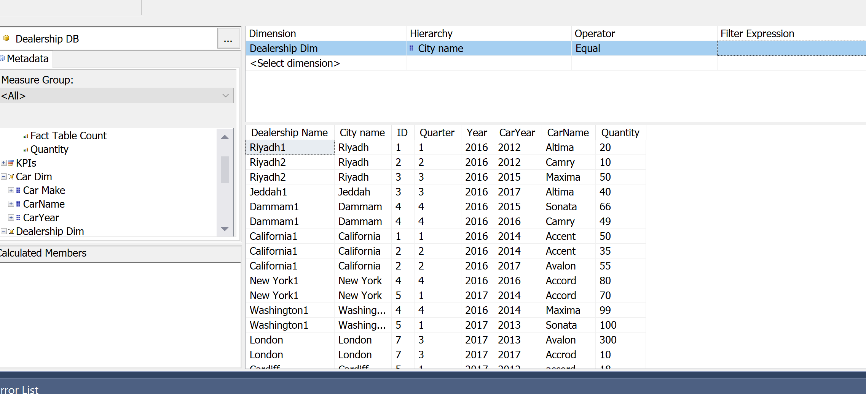

2.A.2: Roll Up using SQL Query:

Select Dealership_Dim.DealershipName,SUM(Fact_Table.Quantity)

From Dealership_Dim,Fact_Table

where Dealership_Dim.ID=Fact_Table.DealershipID

Group By Dealership_Dim.DealershipName

2.B.2: Roll Up using SQL Data Tools 2013:

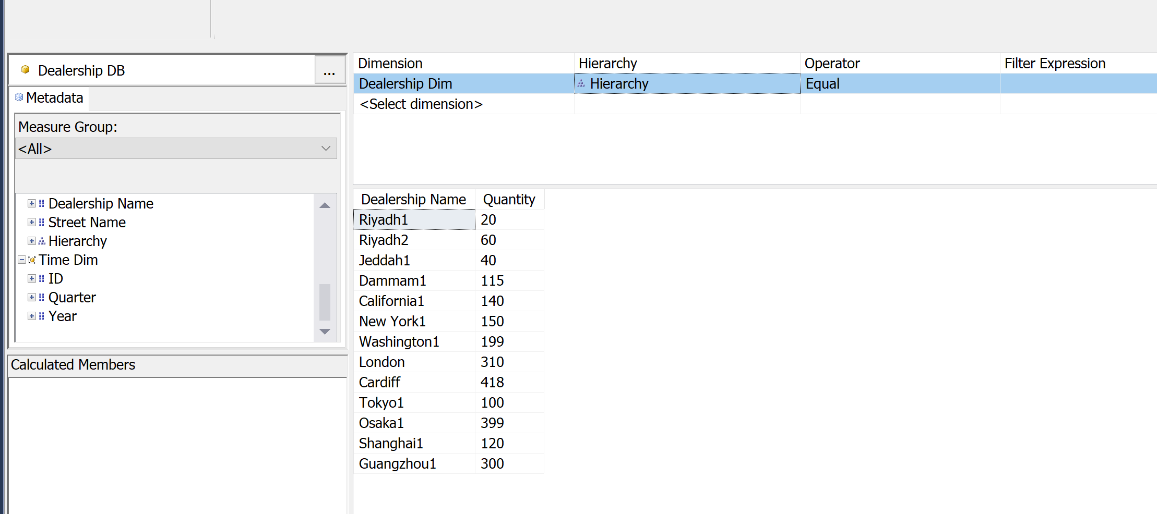

2.A.3: Slice Operation using SQL Query:

SELECT Car_Dim.CarName, Dealership_Dim.DealershipName , City.CityName,Time_Dim.ID

,SUM(Fact_Table.Quantity)

From Dealership_Dim,City,Time_Dim,Car_Dim, Street, Country,Fact_Table

where Dealership_Dim.ID=Fact_Table.DealershipID AND

Fact_Table.CarID=Car_Dim.ID AND

Fact_Table.TimeId = Time_Dim.ID and Street.ID = Dealership_Dim.StreetID and Country.ID=city.CountryID and Street.CityID=City.ID AND City.CityName='Riyadh'

Group by Car_Dim.CarName, Dealership_Dim.DealershipName,City.CityName, Time_Dim.ID

2.B.3: Slice Operation using SQL Data Tools:

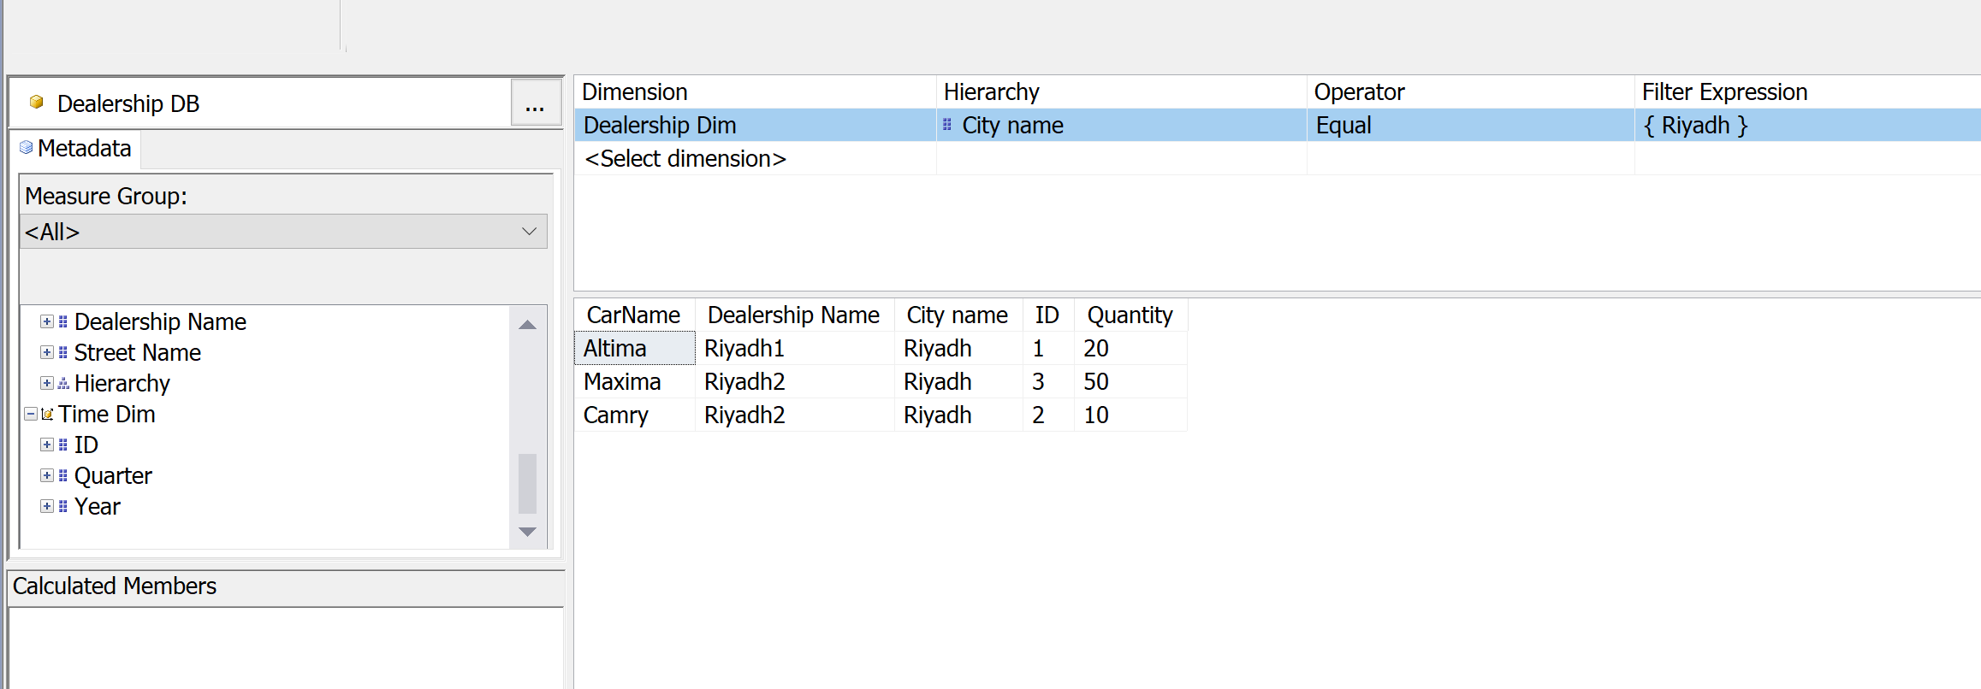

3. Overall look considering all levels of dimension hierarchy:

